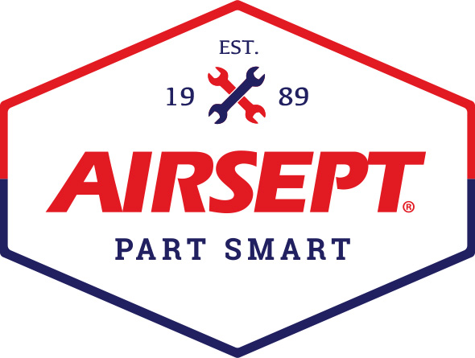

News Release

AirSept Selects Marion Parkes as Procurement Manager

Atlanta – May 10, 2022 – AirSept, a leading manufacturer of award-winning innovative repair solutions for the automotive aftermarket, is pleased to announce the addition of Marion Parkes as the company’s new Procurement Manager. Parkes is responsible for both direct and indirect strategic sourcing strategies and processes and will oversee the establishment of best practices for procure-to-pay processes for all transactions. She also manages all vendor relationships and contractual KPIs and metrics to ensure product pricing, discounts and rebates are properly applied.

Parkes has over 20 years of experience in supply chain management and retail disciplines and is proficient in Dynamics, D365, Manhattan Inventory Optimization and Scorecard Management. She is based at AirSept’s corporate headquarters in Atlanta.

Parkes was formerly Purchasing Manager for Genuine Parts Company, where she was responsible for purchasing and inventory of over 300 million dollars of finished goods at five hubs supporting 57 NAPA distribution centers. She has extensive experience in under car and heavy-duty product categories. As the lead on the NAPA inventory steering committee, she was adept at improving inventory turns, spend, profit and service levels while also making recommendations on purchasing policies, product quality, process improvement and vendor collaboration.

AirSept President Aaron Becker said, “This is a new position for AirSept and one that has long been needed, especially after the last two years of challenging supply chain issues. We are fortunate to have Marion join us to manage vendor relations, forecasting, inventory planning and quality control. She has excellent team-building skills that have been apparent since day one, a penchant for detail, and is skilled at sourcing the highest quality materials while also achieving cost savings. As we move to aggressively introduce AirSept products to new markets, we are very fortunate to have someone with Marion’s depth of expertise as part of our growing senior leadership team.”

For more information about AirSept’s award-winning professional tools and equipment, or the latest company news, visit www.airsept.com. call 800.999.1051, or email information@airsept.com.
# # # #

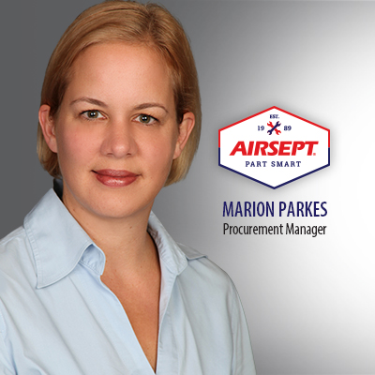
Image Attached:

About AirSept
In 1989 AirSept created the first long-lasting solution to the problem of unwanted mold and mildew odor in automobile air conditioning systems. The product quickly became popular and in 1991 AirSept was incorporated as a company. AirSept began partnering with global OEMs and suppliers to not only market its Cooling Coil Coating, but to also develop other unique, new problem-solving products. From those humble beginnings, AirSept has grown to be the industry leader in the development of OEM and aftermarket solutions to complex repair problems. AirSept products are designed to save time, money and labor. For more information, visit AirSept.com.

For further product information, contact:
Aaron Becker, President
AirSept
678-973-2287
abecker@airsept.com

Leslie Allen
Owner
Wildcat Communications
615-429-7965
leslieallen.wildcat@gmail.com

